**Creator’s Statement:** “Breakfast Nightmare”

**Artistic Vision**

The purpose of my soundscape is to reflect how easily distractions can lead to unexpected and even dangerous situations. I chose to depict a morning routine where I was cooking breakfast but got distracted by other tasks, resulting in the food catching fire. In the rush to get to class, I had no choice but to abandon the burnt breakfast and settle for a quick bowl of cereal. This narrative is relatable and demonstrates how easily we can overlook important things when we’re trying to juggle multiple tasks.

**Challenges and Process**

One of the primary challenges I faced was learning how to use Audacity effectively. As someone new to audio editing, getting familiar with the different tools and effects took time. I wanted to create a cohesive soundscape that smoothly transitioned from the sounds of cooking to the chaos of the fire, and then to the calm resolution of simply grabbing cereal. In terms of the narrative flow, it was tricky to make the sequence of events feel natural without abrupt transitions. I worked to ensure that the sound of the food catching fire and the rushed ending didn’t feel too sudden, but rather contributed to the theme of distraction and urgency.

**Technical Execution**

To create the soundscape, I used multiple effects and tools in Audacity:

1. Cutting and moving clips: I cut several cooking sounds (like the coffee making, fire alarm/extinguisher, and sizzling) and repositioned them to fit the pacing of the story.
2. Fade In/Out: I applied fade-in and fade-out effects to transition from the calm beginning of preparing breakfast to the escalating tension when the food started to burn.
3. Reverb: Reverb was added to the fire alarm to make it sound more distant and alarming, emphasizing the sudden shift from normalcy to panic.
4. Noise Cancellation: I used noise cancellation to clean up some background noise in the audio to make the cooking and fire sounds stand out.

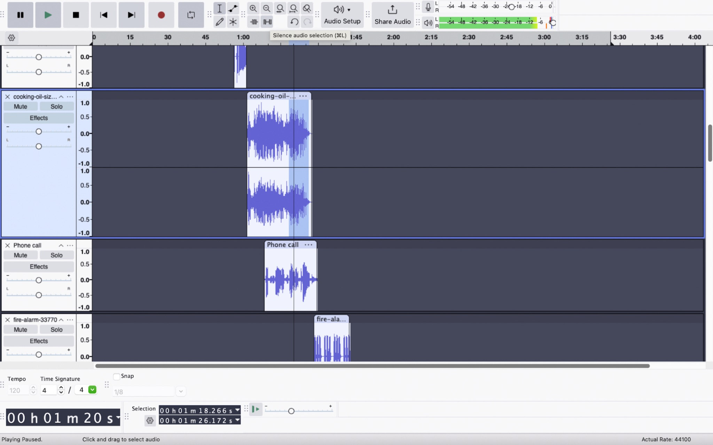

Below are some examples of the tools I used in screenshots:

1. Silence Audio Selection Tool: To control the pacing of the scene, I silenced certain parts of the audio. This allowed me to focus attention on key sounds, such as the sizzling of food and the alarm, without unnecessary background noise.

Screenshot 1: listed above

1. Trim Audio Outside Selection Tool: I used the trim tool to cut out unwanted audio that was outside the selected section, allowing me to focus on the critical moments in the soundscape, like the cooking process and the fire alarm.

Screenshot 2: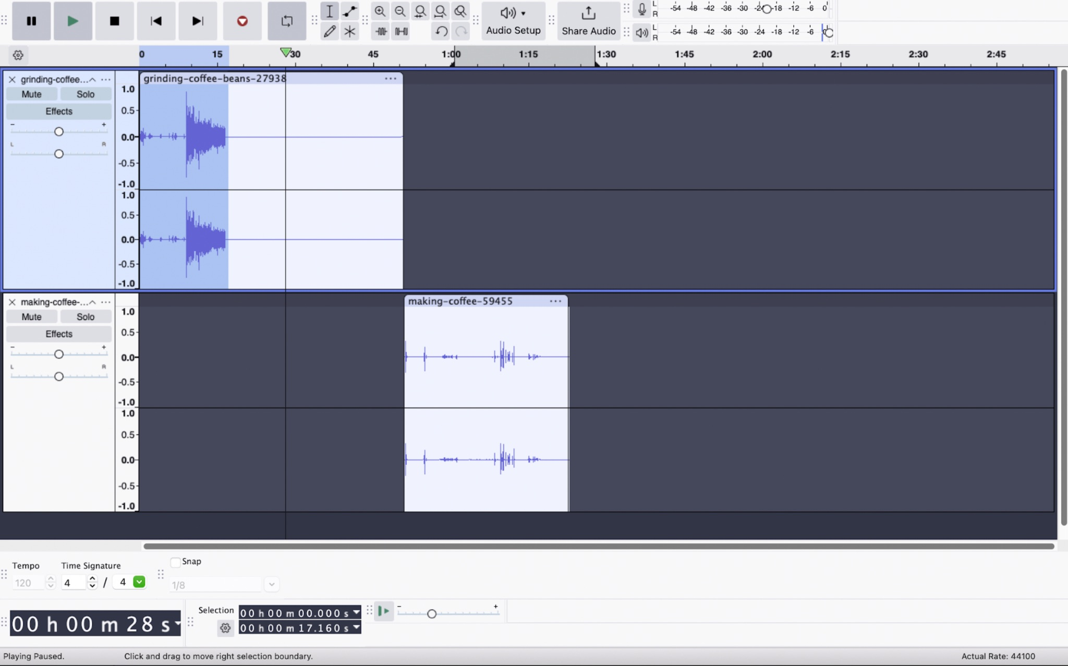

1. Grab Tool: Finally, I used the grab tool to rearrange the audio clips, spacing them out for a more natural flow. This ensured that each sound transition—from calm cooking to panic—felt coherent and intentional. 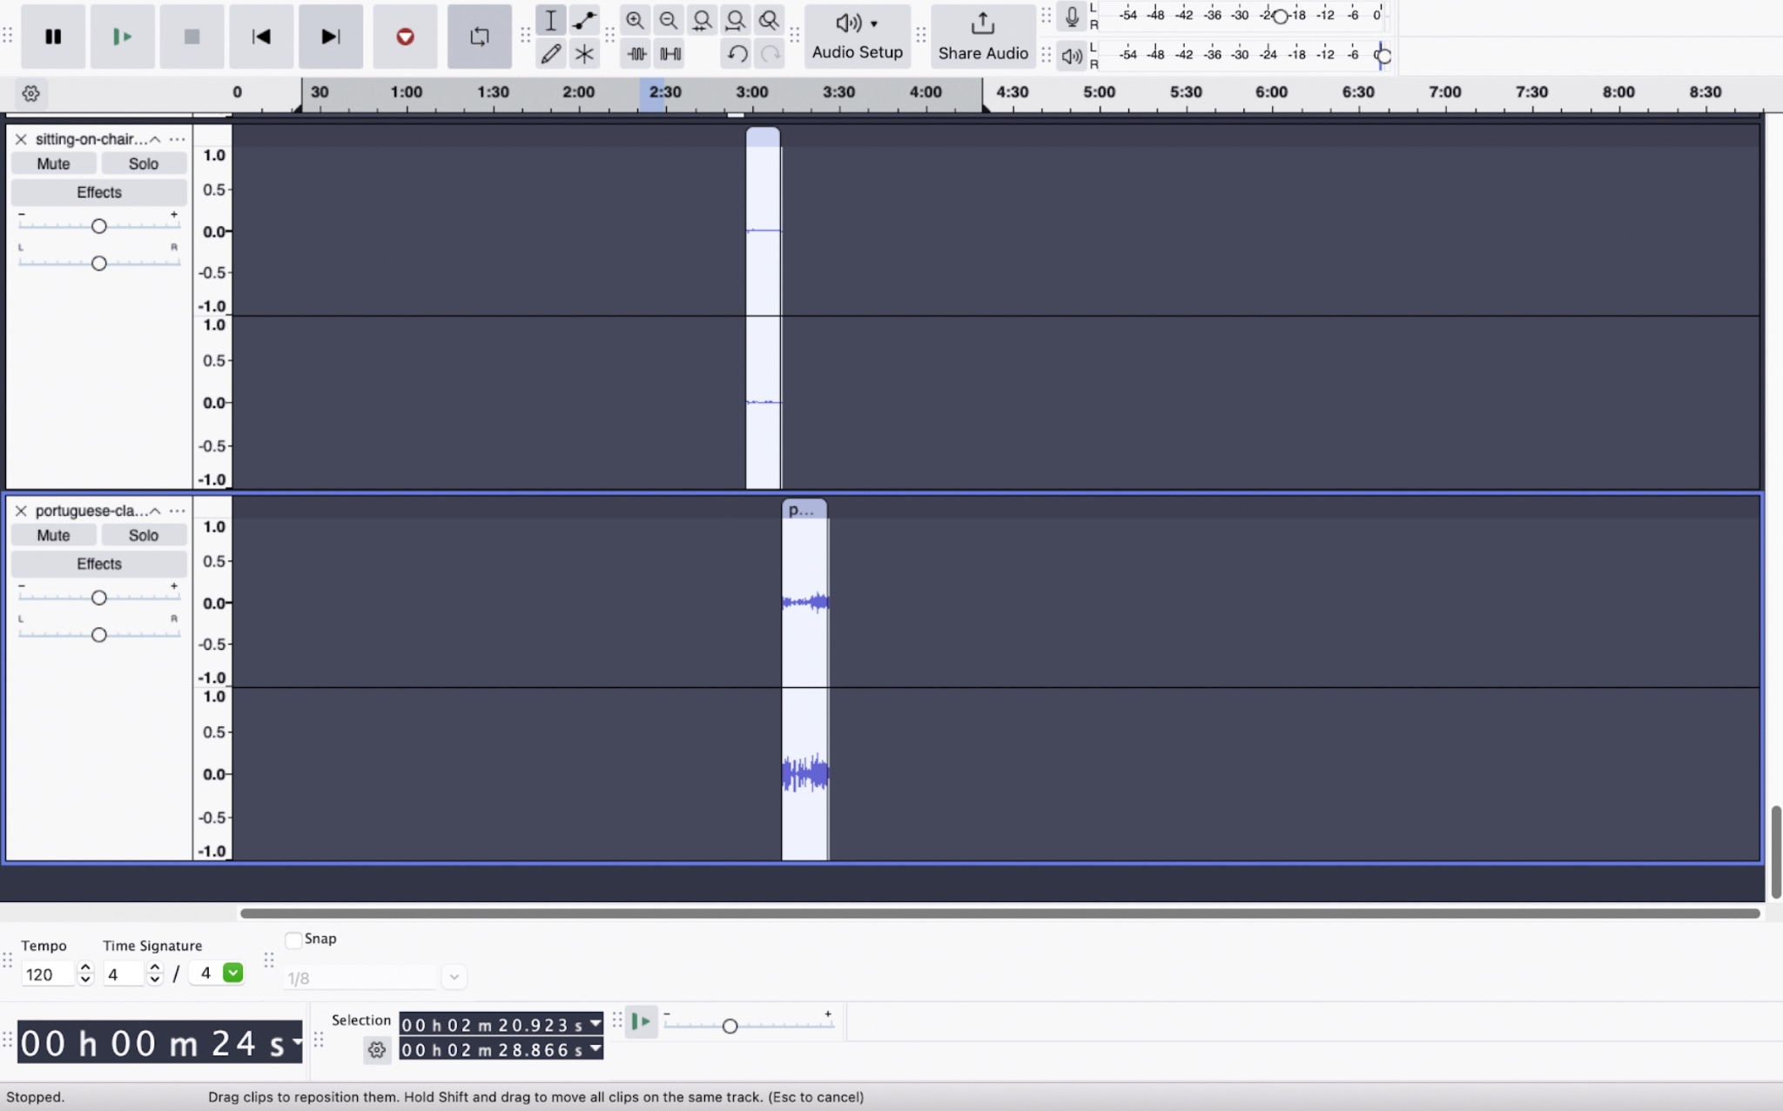

Screenshot 3:

**Real-World Problem**

The soundscape addresses the real-world issue of how multitasking and distractions can lead to dangerous situations in everyday life, like cooking a meal and inadvertently causing a fire when attention is diverted elsewhere.

**Stakes**

The stakes involve personal safety, the potential destruction of property, and lost time. In the context of the soundscape, a kitchen fire caused by distraction while cooking breakfast poses an immediate danger, emphasizing how easily accidents can happen.

**Target Audience**

The target audience is primarily college students and young adults who are balancing hectic schedules filled with classes, assignments, and personal responsibilities. They often rush through daily routines, leaving room for distractions and mistakes.

**Why That Audience?**

This audience frequently experiences situations where time pressure and multitasking lead to distractions, making the soundscape relatable to their lives. Many may have already encountered near-mishaps, such as forgetting to turn off an appliance or burning food due to rushing or being preoccupied.

**What Do You Want Them to Know, Believe, or Do?**

I want the audience to be more mindful and aware of how multitasking can lead to unintentional mistakes. The goal is for them to recognize the importance of focusing on the task at hand, especially during activities like cooking that can result in dangerous consequences if neglected.

**Potential Audience Resistance**

Some listeners may downplay the significance of small distractions or think that minor accidents, such as burning breakfast, are not serious enough to warrant change. They may believe that multitasking is necessary in their fast-paced lives and view it as unavoidable.

**Design Strategy**

The design strategy was to tell the story entirely through sound, starting with the peaceful routine of cooking and leading to the chaos of a fire. The sequence of sounds builds tension—from the cooking oil sizzling, to alarms blaring, to a rushed decision to abandon the meal and quickly eat cereal before heading to class. The goal was to immerse the audience in the escalating stress of the moment, using sound to convey the emotional shift from calm to panic.

**Results**

The final soundscape successfully captures the experience of a chaotic morning where a simple distraction leads to a fire. It starts with peaceful cooking sounds, escalates into a tense situation with alarms and panicked actions, and resolves in a hurried decision to eat cereal instead. The story shows how quickly things can go wrong when you're not paying attention.

**What You’ve Learned**

This project taught me a lot about the delicate balance of sound and pacing. The technical side of Audacity was a learning curve, but once I understood how to use the tools, it became easier to create a coherent soundscape. The final product captures the message I aimed for: that distractions, even small ones, can lead to unintended consequences, but sometimes, we just move on because life doesn’t stop.

Citations

1. Cooking Oil Sizzle 1

Author: Floraphonic

Source: [Pixabay.com](http://pixabay.com)

License: Free for commercial use, no attribution required

2. Grinding Coffee Beans

Author: Pixabay

Source: [Pixabay.com](http://pixabay.com)

License: Free for commercial use, no attribution required

3. Making Coffee

Author: Pixabay

Source: [Pixabay.com](http://pixabay.com)

License: Free for commercial use, no attribution required

4. Drinking Tea (ASMR)

Author: Pixabay

Source: [Pixabay.com](http://pixabay.com)

License: Free for commercial use, no attribution required

5. Big Cabinet Doors Open and Close

Author: Pixabay

Source: [Pixabay.com](http://pixabay.com)

License: Free for commercial use, no attribution required

6. Spray

Author: Pixabay

Source: [Pixabay.com](http://pixabay.com)

License: Free for commercial use, no attribution required

7. Fire Alarm

Author: Pixabay

Source: [Pixabay.com](http://pixabay.com)

License: Free for commercial use, no attribution required

8. Estintor

Author: u_g0akwz8ml1

Source: [Pixabay.com](http://pixabay.com)

License: Free for commercial use, no attribution required

9. Cereal Box

Author: Pixabay

Source: [Pixabay.com](http://pixabay.com)

License: Free for commercial use, no attribution required

10. 065388_Cereal Pouring

Author: Pixabay

Source: [Pixabay.com](http://pixabay.com)

License: Free for commercial use, no attribution required

11. Eating Cereal

Author: Pixabay

Source:[Pixabay.com](http://pixabay.com)

License: Free for commercial use, no attribution required

12. Searching for Keys

Author: Pixabay

Source: [Pixabay.com](http://pixabay.com)

License: Free for commercial use, no attribution required

13. Kyes

Author: Pixabay

Source: [Pixabay.com](http://pixabay.com)

License: Free for commercial use, no attribution required

14. Main Door Opening-Closing

Author: Pixabay

Source: [Pixabay.com](http://pixabay.com)

License: Free for commercial use, no attribution required

15. Walking

Author: Pixabay

Source: [Pixabay.com](http://pixabay.com)

License: Free for commercial use, no attribution required

16. Wooden Chair Move

Author: Pixabay

Source: [Pixabay.com](http://pixabay.com)

License: Free for commercial use, no attribution required

17. Sitting on Chair

Author: Pixabay

Source:[Pixabay.com](http://pixabay.com)

License: Free for commercial use, no attribution required

18. Portuguese Class

Author: Pixabay

Source: [Pixabay.com](http://pixabay.com)

License: Free for commercial use, no attribution required